Name: Isabelle Parsons
Student number: 12120137
Course: ACCT11081
Due date: 29-09-20

Steps 7-11
Step 7
Analysis of Inventories
Data of Inventories

Year | 2017  Annual report | 2018  Annual Report | 2019  Annual Report
Inventories (Current Assets)
Work in Progress | $37,254,073 | $31,395,917 | $70,549,285
Completed Stock | $77,708,199 | $52,911,480 | $59,375,950
Total Current Inventories | $114,962,272 | $84,307,397 | $129,925,235
Inventories (Non-Current Assets)
Work in progress | $45,579,688 | $40,093,105 | $40,237,825
Completed Stock | $27,546,227 | $20,511,096 | $22,569,721
Total Non-Current inventories | $73,125,915 | $60,604,201 | $62,807,546
Notes to Fin. Statement | 18 | 18 | 16
Index to Notes to Fin. Statement | Page 78 | Page 70 | Page 71
Index to Significant Acc. Policies | Page 59 | Page 53 | Page 54

Key features of Inventories:
- Inventories, work in progress and land for the purpose of resale and they are valued at costs or Net realisable value whichever is lower.

- Meaning of Net realisable value:
Particulars | Amount $
Estimated sales price (In ordinary course of business) | Xxxx
Less: Estimated cost for the completion | Xxxx
Less: Estimated selling expenses | Xxxx
Net realisable value | XXXX

- Meaning of Cost (Includes):
Particulars | Amount $
Acquisition Cost | Xxxx
Add: Development Costs | Xxxx
Add: Cost of Holding | Xxxx
Add: Interest Cost which is directly attributable | Xxxx
Total Cost | XXXX

- Conditions for: Current as well as Non-Current Inventory Assets:
As per the companies policies if any one of the following three conditions are satisfied then it will be treated as “Current inventory Assets” and if not then it is said to be “Non-Current Inventory Assets”:
Conditions
1): It is anticipated to be sold, Consumed or to be realized as per normal operating cycle;
2): It is acquired or held for the basic purpose of trade or to be traded;
3): It is anticipated to be realised within 12 months of the reporting date.

KCQ’s
- Whether inventories amounts are small or large in numbers?
The amount of the inventories are being recorded in Millions and it seems to be large in nature.

- The inventories figures means what?
It shows that, at the Balance sheet date what are the closing inventories which are in the hands of company by way of “Work in progress” and “Completed stock”.

- What company does not disclose about the Inventories?
The Company does not disclose about the “Raw Material” closing stock while disclosure made in the Annual reports.

- Whether company have changed its inventory policy during the years?
No. Company have not changed its inventory policy within these years.

- Whether company have disclosed its system of inventory such as “Periodic or Perpetual”?
No. Company have not disclosed its system of inventory in the Annual report.

- Areas that could be improved while inventory system?
The Company should mention the system they are using such as “Periodical or Perpetual”. It should also mention the method for valuation of inventory such as LIFO, FIFO or Weighted Average.

Step 8
Screen shot of last set up
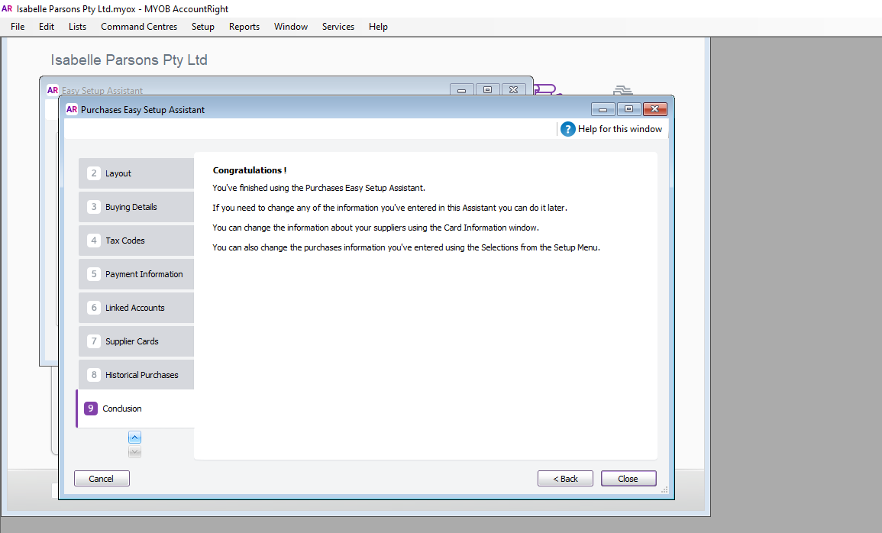
Screen shot of last entered transaction
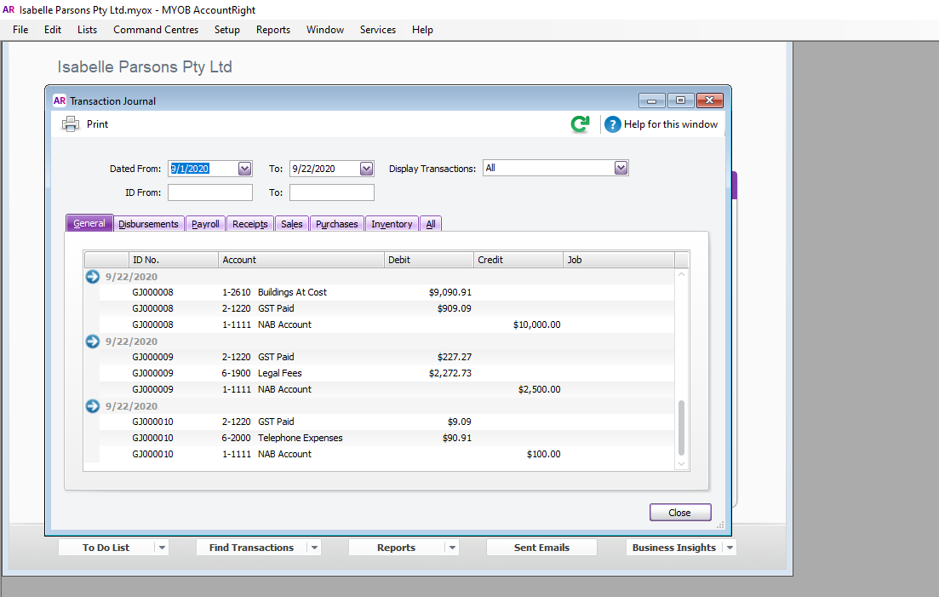
Screen shot of Ezylearn MYOB Online training skills test

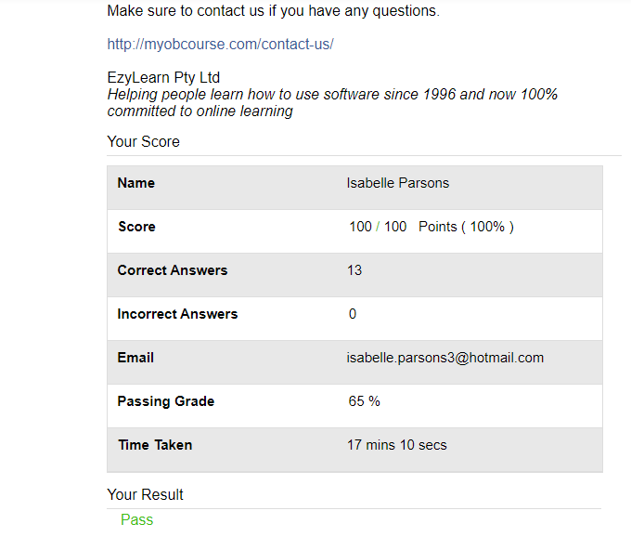

Step 9

Statement of Cash Flow
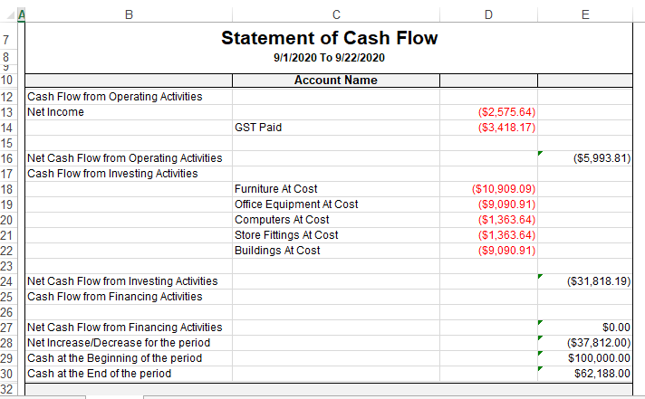

Balance Sheet
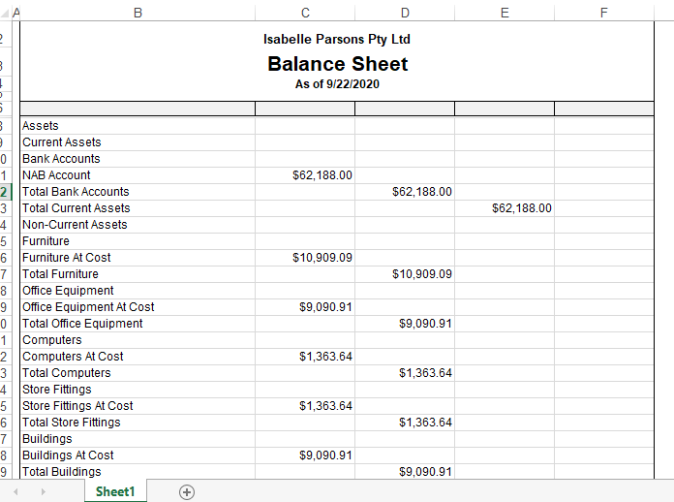
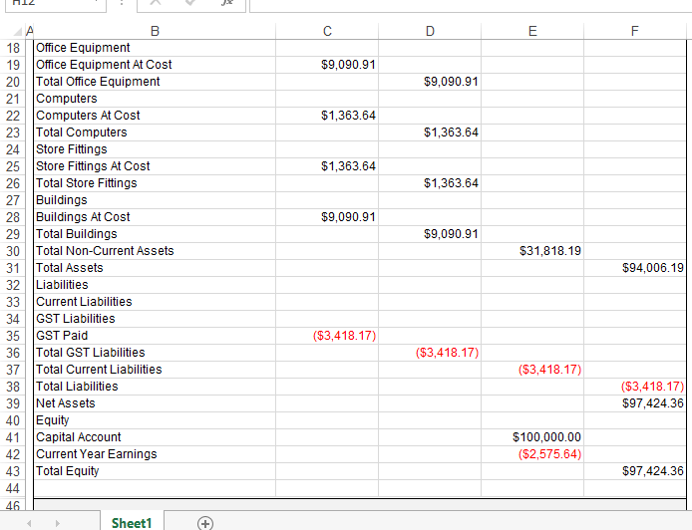

Profit and Loss Statement
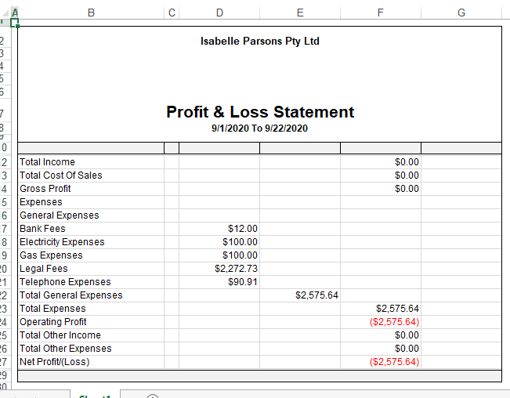

GST Summary
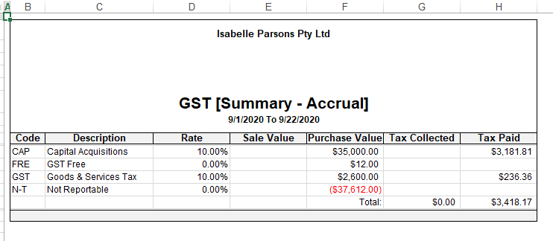

General Journal and ten transactions
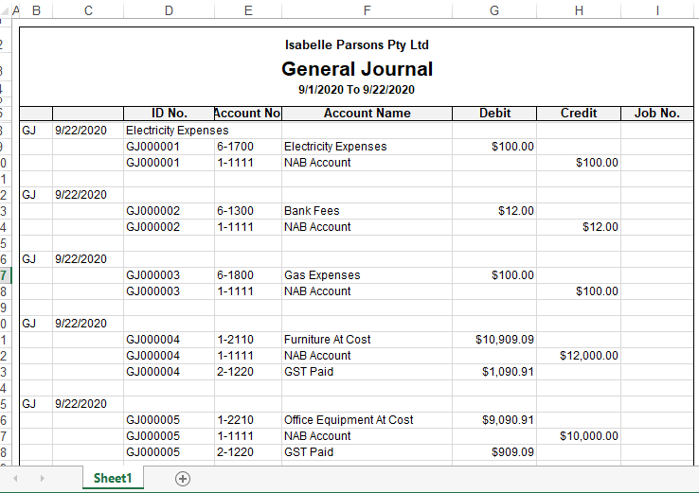
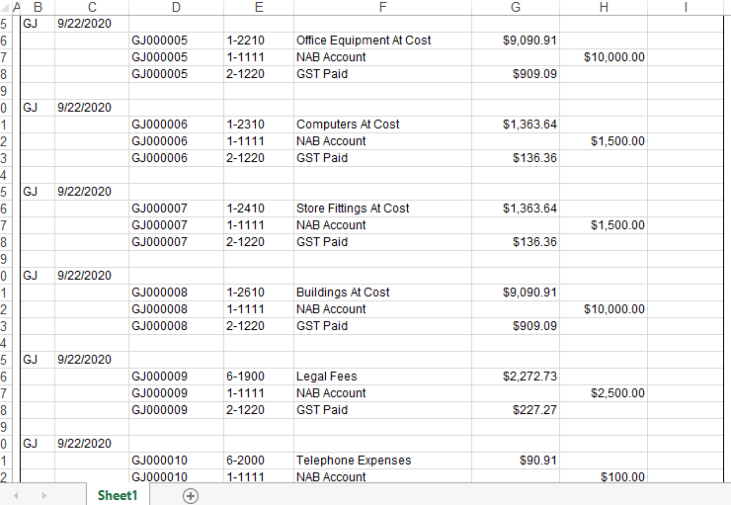
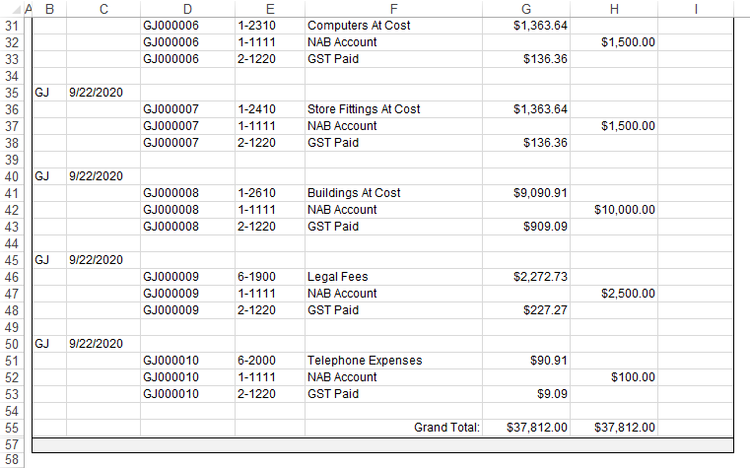

Bank Register
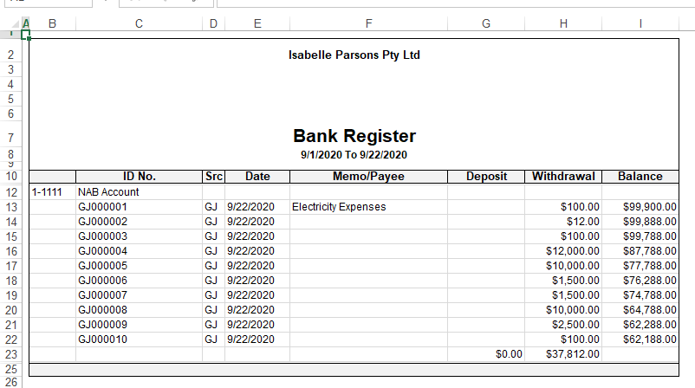

These are the following tools which are being preferred to make the analysis of Financial statement:
Tools for Analysis of “Financial Statement”
1) Comparative statements
2) Comparative Income statements
3) Comparative Balance Sheet
4) Common Size Statements
5) Trend Analysis
6) Average Analysis
7) Statements of changes in working capital
8) Cash Flow Statement
9) Fund Flow Statements
10) CVP Analysis
11) Ratio Analysis

The below table represents the financial health by calculating the ratio of each year from 2017 to 2019:
Profitability Ratio
Net Profit Ratio = Profit for the year / Net revenue or Sales
2017 | 5,310,382/123,709,314 = 4.29%
2018 | 13,935,908/150,736,461 = 9.25%
2019 | 11,386,819/154,690,070 = 7.36%
Gross Profit Ratio = Gross Profit / Net Revenue or Sales
2017 | 30,966,433/123,709,314 = 25.03%
2018 | 29,908,299/150,736,461 = 19.84%
2019 | 28,426,728/154,690,070 = 18.38%

There are many more ratio analysis it is just a starting point of analysis of company’s financial health in relation to the profit margin. As shown in the above calculation, it is clear that Finbar’s net profit is having no trend set up, whereas the Gross profit has the decreasing trend that is from 25.03% to 18.38% in the three years duration. Hence there are lots of calculation of the ratio under the different headings.

Step 10

Depreciation: Analysis of Property, Plant and Equipment
PPE | Property  $ | Office Furniture & Equipment  $ | Plant and Equipment  $ | Fixtures and Fittings  $ | Total  $
2017 Page 73 | 186,925 | 60,122 | 319,899 | 7,636 | 574,582
2018 Page 66 | 171,766 | 46,425 | 895,684 | 6,109 | 1,119,984
2019 Page 67 | 171,766 | 41,562 | 888,978 | 4,887 | 1,107,193

Journal entries for Depreciation for each year
Date | Accounts Title | Debit Amount  $ | Credit Amount  $
30 June 2017 | Depreciation & Amortization | 574,582
 | Property |  | 186,925
 | Office Furniture & Equipment |  | 60,122
 | Plant & Equipment |  | 319,899
 | Fixtures & Fittings |  | 7,636
 | (To record depreciation & amortization against each PPE)
30 June 2017 | Property | 186,925
 | Office Furniture & Equipment | 60,122
 | Plant & Equipment | 319,899
 | Fixtures & Fittings | 7,636
 | Accumulated Depreciation & Amortization |  | 574,582
 | (To record transfer of depreciation & amortization amount in the Accumulated Dep. & Amor. account)
30 June 2017 | Statement of Profit & loss | 574,582
 | Depreciation & Amortization |  | 574,582
 | (To record transfer of Dep. & Amor. Amount to Statement of P&L)

Date | Accounts Title | Debit Amount  $ | Credit Amount  $
30 June 2018 | Depreciation & Amortization | 1,119,984
 | Property |  | 171,766
 | Office Furniture & Equipment |  | 46,425
 | Plant & Equipment |  | 895,684
 | Fixtures & Fittings |  | 6,109
 | (To record depreciation & amortization against each PPE)
30 June 2018 | Property | 171,766
 | Office Furniture & Equipment | 46,425
 | Plant & Equipment | 895,684
 | Fixtures & Fittings | 6,109
 | Accumulated Depreciation & Amortization |  | 1,119,984
 | (To record transfer of depreciation & amortization amount in the Accumulated Dep. & Amor. account)
30 June 2018 | Statement of Profit & loss | 1,119,984
 | Depreciation & Amortization |  | 1,119,984
 | (To record transfer of Dep. & Amor. Amount to Statement of P&L)

Date | Accounts Title | Debit Amount  $ | Credit Amount  $
30 June 2019 | Depreciation & Amortization | 1,107,193
 | Property |  | 171,766
 | Office Furniture & Equipment |  | 41,562
 | Plant & Equipment |  | 888,978
 | Fixtures & Fittings |  | 4,887
 | (To record depreciation & amortization against each PPE)
30 June 2019 | Property | 171,766
 | Office Furniture & Equipment | 41,562
 | Plant & Equipment | 888,978
 | Fixtures & Fittings | 4,887
 | Accumulated Depreciation & Amortization |  | 1,107,193
 | (To record transfer of depreciation & amortization amount in the Accumulated Dep. & Amor. account)
30 June 2019 | Statement of Profit & loss | 1,107,193
 | Depreciation & Amortization |  | 1,107,193
 | (To record transfer of Dep. & Amor. Amount to Statement of P&L)

KCQ’s
- Whether company have changed its depreciation method during these three years?
No. Company does not changed its depreciation method within these three years.

- How depreciation and amortization effect the financial statements?
The depreciation and amortization reduces the profit of the company because it is treated as expense of the company.

- Which method of depreciation have been used by the company?
Company used “Written down value method or Diminishing balance method”.

- Whether Company could able to manipulate the depreciation entries?
Yes. Company could be able to do so by making the “Revaluation of the Assets” in each year such as enhancing the value of the assets and deprecating the bigger amount than earlier.

- Whether the depreciation is essential expense of the Company?
Yes. It is the essential expense of the company because it reduces the Net income of the company and it also reduces the Income Tax amount on it consequently.

Step 11
Feedback given:

PEER FEEDBACK SHEET: Assignment Steps 7-10
Feedback From: Isabelle Parsons
Feedback To: Danielle Mills .

 | My Comments
Step 7  Inventories | I think it’s great how you put your data into a table, I personally find it a lot easier reading it this way. Very thorough investigation into your firms inventories, and I like how you have numbered all of the questions that needed to be answered.
Step 8 | All of your screenshots look completed. Good job in completing the quiz in 2 minutes!
MYOB set up
MYOB training
MYOB quiz
Step 9  Business transactions All Journals report  Financials and discussion | I also had difficulty completing this step, as I didn’t know what ten transactions to focus on for my firm. You have chosen some very smart and appropriate transactions for your firm.  Your analysis and reflections on this step is really detailed and it’s helpful how you have split the parts of it up.
Step 10  Depreciation | I found it really good how you gave a definition of what depreciation is, but then described it in your own words afterwards. It really shows your understanding of the term.
Overall | Overall, this is a really strong assignment and I believe you are going to do great, good job!

PEER FEEDBACK SHEET: Assignment Steps 7-10
Feedback From: Isabelle Parsons
Feedback To: Sarah Miles .

 | My Comments
Step 7  Inventories | This is a very strong step. I really like how you have highlighted figures in red to show a negative, it makes it stand out. Your description/KCQ’s of this step is very detailed, and it shows that you have put a lot of thought into it.
Step 8 | All of your screenshots are good, and good job on getting 100% on your MYOB test!
MYOB set up
MYOB training
MYOB quiz
Step 9  Business transactions All Journals report  Financials and discussion | Your transactions are relevant to your firm, and all of your reports look good. I really like how you have classified your expenses in red. Your KCQ’s of each statement really shows your understanding for the terms and you were sure to mention the elements of the accounting equation.
Step 10  Depreciation | I really like that you have got tables in this step, I personally find it easier reading tables rather than descriptions. Your KCQ’s are really strong in this step, I like how you add in what you notice with your firms figures. It shows you have a deeper understanding of what the figures mean.
Overall | Overall a really good assignment. Good job!

PEER FEEDBACK SHEET: Assignment Steps 7-10
Feedback From: Isabelle Parsons
Feedback To: Kevin Bingham

 | My Comments
Step 7  Inventories | I really like how you have put your inventory figures into a table. I am a visual learner, so this really helped me understand your firms inventory figures, and clearly see the differences between the years.  It’s good that you did a bit of investigating to find out what the work in progress inventory was listed in the notes.
Step 8 | All screenshots are included in this section. I think it’s really good how you have added figure 6 and explained where you went wrong in the quiz.
MYOB set up
MYOB training
MYOB quiz
Step 9  Business transactions All Journals report  Financials and discussion | Your KCQ’s are strong in this section, and you are not afraid to mention where you make a mistake, as you also mention how you remedied it.  The ten transactions look good and relevant to your firm.  All of the relevant reports have been shown, and you have explained in detail what these mean to yourself and your company.
Step 10  Depreciation | Again, really love the tables in this step. You have answered all of the questions in the assignment task in a very detailed manner.
Overall | Really strong assignment. I love how much detail you have added into your KCQ’s, it shows your understanding for your firm.

Feedback received:

Feedback From: Danielle Mills
Feedback To: Isabelle Parsons .

 | My Comments
Step 7  Inventories | I think you’ve produced some great content on this step Isabelle. It’s great your company also broke down inventories into further categories, my firm didn’t do this at all! I found it very frustrating to get a clear picture. This step was really simple and easy to read and understand, I’m a very visual person so producing your information into tables like you’ve done was a great idea. It didn’t even cross my mind to do something like this!
Step 8 | Your screen shots and test results look all good to me. 100%, well done!
MYOB set up
MYOB training
MYOB quiz
Step 9  Business transactions All Journals report  Financials and discussion | You included extra reports! I love this idea and once again, the thought didn’t even cross my mind. I found the GST summary to be very interesting and useful. Another great idea using the ratio’s analysing your reports. I think this level of analysis shows a high level of understanding and knowledge.
Step 10  Depreciation | I think the journals you’ve chosen are solid and definitely represent end of year journals.
Overall | I think you’ve done a great job with this assignment Isabelle. You’ve clearly laid out the information in a manner that is easy to read and understand. As a visual learner, I really liked this aspect Good luck!

PEER FEEDBACK SHEET: Assignment Steps 7-10 Feedback From: Sarah Miles
Feedback To: Isabelle Parsons .

 | My Comments
Step 7  Inventories | I love how you have set out the meaning of NRV & cost . I am a very visual person so this has helped with my understanding too – great work.  With regards to the question is your inventory large? I compared the Inventory asset account to the other accounts in currents assets on the Balance Sheet. I found Inventory made up 50% of my firms current assets – I thought this was quite high!  Another thing – I think you have answered the questions as your KCQ’s. I believe the KCQs should just been anything you find interesting or that confuses you? One of my KCQs was in regards to an Inventory account listed as “second hand units” – I always assumed inventory was “new” stock, but once I thought about it, I understand how it should be included as inventory so I just mentioned that in my word document. I would maybe try to write a few KCQs about some of the concepts you discovered in our firm’s annual report on Inventories to help strengthen this step.  I also suggest you expand on the periodic & perpetual area. Most firms don’t list it in their annual reports but you should be able to identify which system it uses by your annual reports. Let me know if you would like to me to help you anymore on this  Also – have you had any experience with inventory? Even if you haven’t I would mention that so the marker knows you have addressed this point.  With these few little changes I think you will do well with this step.
Step 8 | Great work here!! you aced your test as well!
MYOB set up, training & quiz | Great work here!! you aced your test as well!
Step 9  Business transactions All Journals report  Financials and discussion | The first thing I noticed is your missing the 10 transactions you created – I believe you have to included these in your word document as well otherwise you will miss out on marks for this section! So definitely don’t forget to that  Other than that everything else looks perfect for this step!
Step 10  Depreciation | I love all the graphs you have included – they are really good!  Your journals are very very detailed – its great! Although I think you may need to update the account Statement of Profit & Loss as I thought this was a report (not generally an account).
Overall | Overall, I think you’ve done a great job – just a few minor changes and make sure to include your transactions for step 9! I would hate for you to lose marks for just not including them in your word document.  Good luck with your assignment and exam!

PEER FEEDBACK SHEET: Assignment Steps 7-10 Feedback From: Kevin Bingham
Feedback To: Isabelle Parsons .

 | My Comments
Step 7  Inventories | Your step 7 is set out differently to most others I have seen and that is in a good way. Visually it looks great and all the figures are there in front of you. You are right that you seem to have a large inventory, but I do not see anywhere in this step what type of company this is. Maybe you could at that with a little introduction? I like the way you presented and explained the Net Realizable Value and meaning of cost. With your KCQ, s you could maybe add some of your own thoughts and opinions on what type of inventory they are using and what method they use to calculate the inventory.
Step 8 | Well done in this step, you have covered all the tasks set with the screenshots and passed the test with 100%  Well done.
MYOB set up
MYOB training
MYOB quiz
Step 9  Business transactions All Journals report  Financials and discussion | All your financial statements look in good order. Well done for getting them all out on Word. You seem to have a nice range of transactions in your journals, but I do not see anywhere the 10 made up transactions you need to show as part of the requirements for step 9. Its great that you have included some ratios as part of explain your financials.
Step 10  Depreciation | Once again this is visually great, and all the depreciation figures are there in front of you which gives you a picture of your company. I love all the detail in your journal transactions, and it is great you have put a lot of thought into this.
Overall | Isabelle you have done very well with your draft and have put in a lot of work and effort. Maybe something about your company and the transactions for step 9 will complete a great piece of work.  Like myself there is some letters missing for spelling and some grammar needs touching up. Great Work.

